

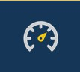
The Dashboard is the first page displayed when logging into the Explanation Based Auditing System (EBAS). The Dashboard automatically displays basic analytics of all uploaded data, for the date range specified.
Return to the Dashboard at any time by clicking the gauge icon.

Square icons in the middle serve as clickable shortcuts. Summary data are provided at the bottom of each shortcut.
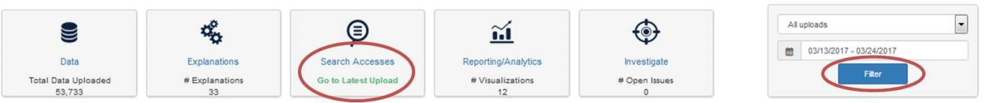

Choose data to be displayed on the Dashboard by specifying upload source and clicking Filter. Click Search Accesses to go to the Search page and view all accesses for the specified date range.
Click Go to Latest Upload to go to the Search page and view only accesses from the latest data upload.

Use the graph and table tiles to quickly analyze your data. Blue hyperlinks (e.g. Manage Saved Searches) within and under each tile take you to more details. Page navigations allow you to sort and review more results where indicated.

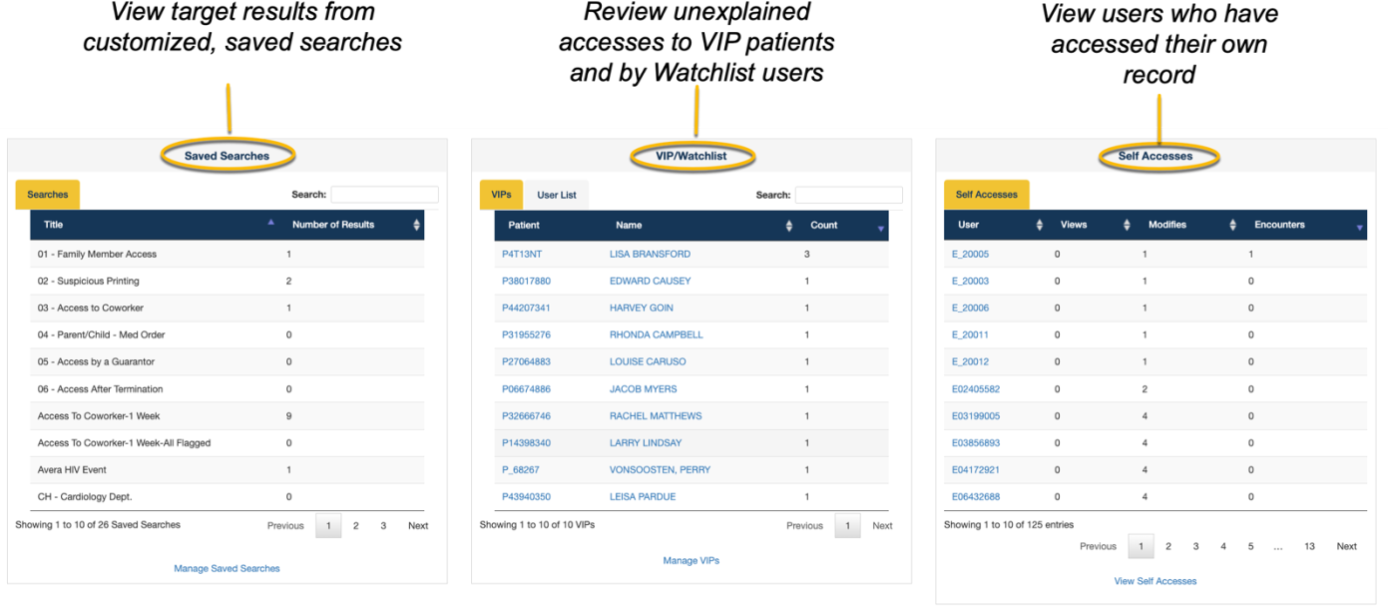

© Maize Analytics 1.04.12.1 info@maizeanalytics.com Phone 615.997.0101 x 2
Duplication or distribution of this document, without Maize Analytics’ expressed content, is prohibited.

